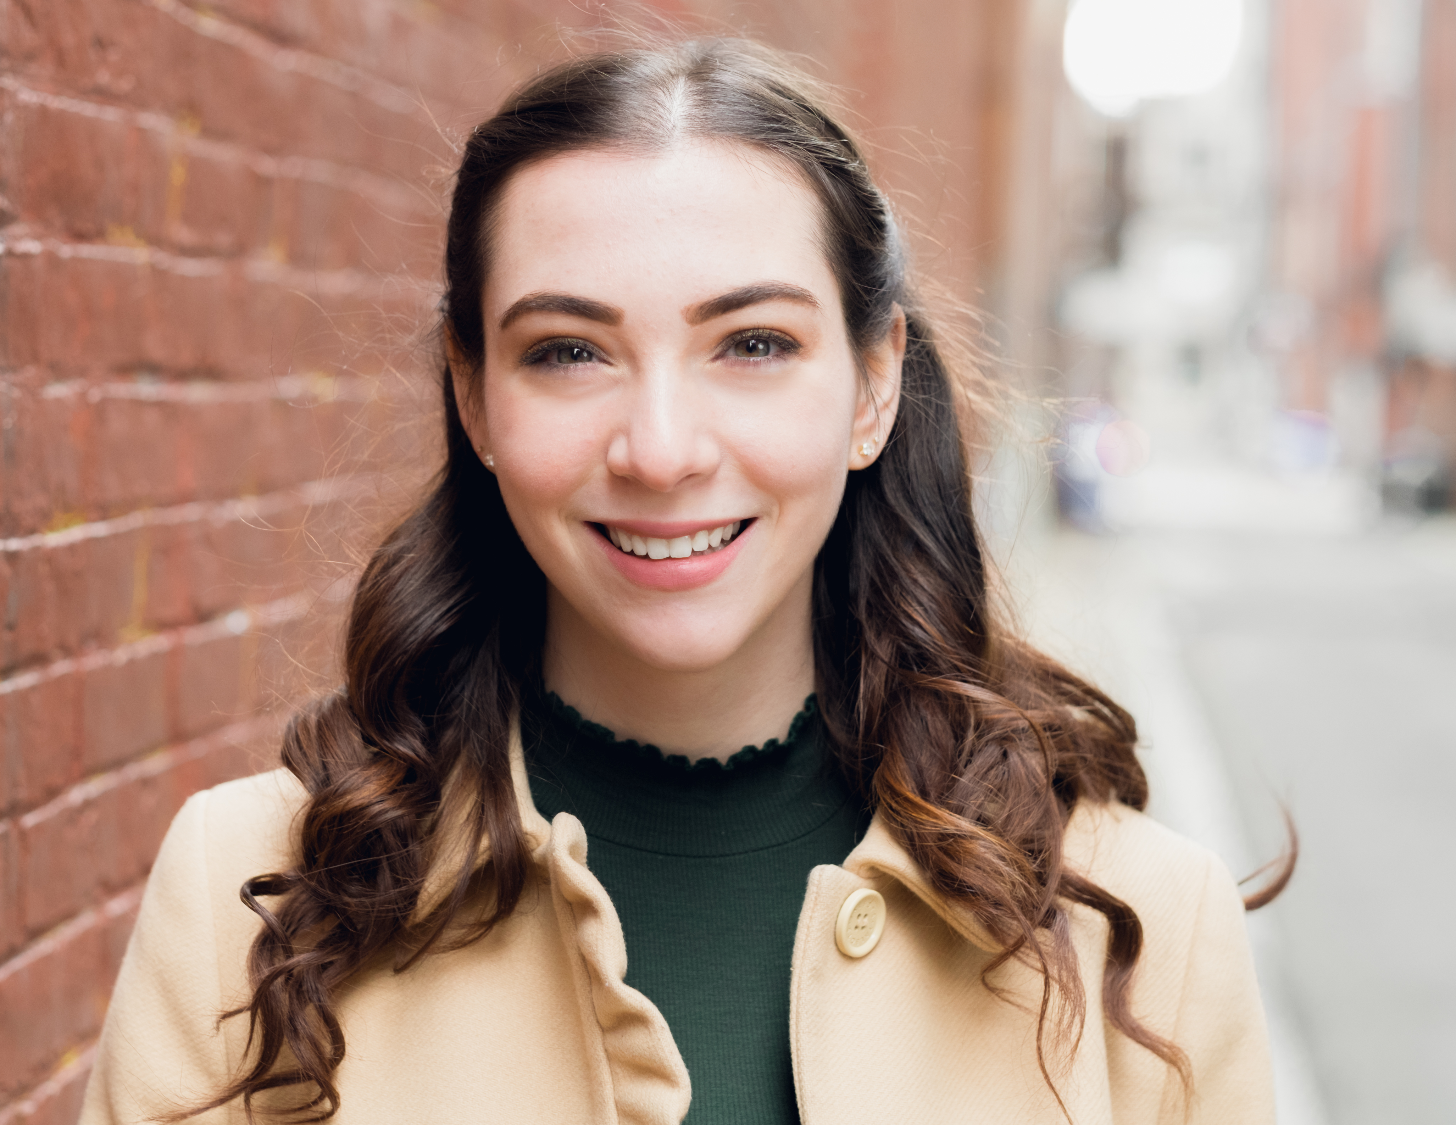
SAMMI SOPRANO
Legit Soprano with Mixed Belt | 5’3”
New York, NY | (929) 266-3492 | officialsammisoprano@gmail.com
PROFESSIONAL THEATRE
Royal Princess Ball (Tour) Various Princesses Dream Parties, Nina Herrmann
Disney Performing Arts Showcase Featured Soloist Disney Performing Arts, Ellie Desautels
A Christmas Carol Youth Chorus The Palace Theatre, Carl Rajotte
EDUCATIONAL THEATRE
Drama Showcase Tina (Tough) AMDA, NY, Diane Ciesla Musical Showcase Featured Soloist AMDA, NY, Brett Teresa Cabaret at the Castle Featured Soloist Manhattanville College, Mark Cherry Showtune (revue) Featured Soloist Manhattanville College, Mark Cherry The 25th… Spelling Bee Olive Ostrovsky Manhattanville College, Bella Calabria Children of Eden Featured Soloist Derryfield Rep. Theatre, Chris Kiley The 25th… Spelling Bee Marcy Park Village Players, Kathleen Hill The Crucible Mary Warren The Derryfield School, Jim Speigel The Phantom of the Opera Madame Giry The Derryfield School, Jim Speigel Godspell Featured Soloist Palace Teen Ap. Company, Carl Rajotte The Wizard of Oz Dorothy Gale Derryfield Rep. Theatre, Kyle Wolcott
FILM CREDITS The Dark Side of Melancholia Lead Mville Video Project, Gavi Loewenstein Open House Featured Continuous Films, Philip Aceto Death Lay Here Lead Mville Video Project, DoubleR3 Afrit Supporting Mville Video Project, DoubleR3 The Guilty Ones Lead The Derryfield School, Sarah Wilson
TRAINING - AMDA NYC Musical Theatre Conservatory ’20
Voice: Carlos Matinez, Dorothy Bishop, Diana Canova, Kristen Acker, Lauren Cook
Musical Theatre: David Cady, Andy Leech, Phillip George, Jay Dias, Mark Cherry, Beverly Meyer
Acting: Diane Ciesla, Clista Townsend, Ray Virta, Tim Corcoran, Michael Perilstein, Bill Westenberg
Dance: Michelle Bruckner, LaQuet Pringle, Andrei Kisselev, Laurena Barros, Bonnie Walker
Voice and Speech: Jacqueline Springfield, Chris Neher, Angela Eckard, Emily Zempel
Masterclass: Jenn Colella, Sierra Boggess, Lindsay Mendez, Tufts University “Beezlebubs”
SPECIAL SKILLS
English Horseback riding (hunter hack <3’), alpine ski racing, strong sight-singer, piano, ukulele, high-
pitched scream, creepy doll face, RP British dialect, Scottish dialect, Teaching music to preschoolers,
good with animals, finding four leaf clovers, belaying experience, US passport, valid drivers license

